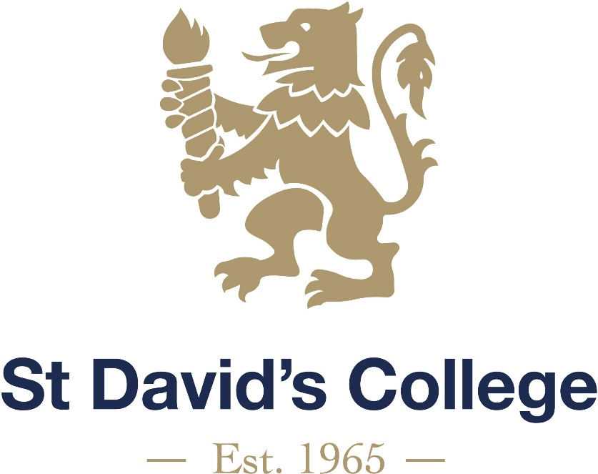

CURRICULUM
POLICY

2024-2025

Curriculum Policy

Date | Review Date | Monitoring | Coordinator | Nominated Governor
01/09/2024 | 01/09/2025 | Annually to Ed Com | Mark Turner | Sam Hepworth

We believe this policy should be a working document that is fit for purpose, represents the school ethos, enables consistency and quality across the school.

Introduction

The school aims to develop the whole person through a broad education founded on Christian principles, a wide choice of interests and activities, and an achievable programme designed to meet the needs of each pupil. The curriculum will be balanced and broadly based to prepare pupils for the opportunities, responsibilities and experiences of adult life.

Aims

We aim to provide an education that enables all pupils to reach their full potential and take their place as full, active members of society. We aim to provide a broad, balanced and relevant curriculum to all pupils and differentiated to meet their individual needs. It will allow pupils to develop a wide range of skills, concepts and knowledge and equip them for the next stages of their development, whether academic or vocational.

The curriculum will offer different pathways through learning in order to suit aptitudes and interests of learners and to meet the requirements of employers and others. The curriculum will also develop attitudes to learning by promoting independent learning leading to lifelong learning.

The curriculum will be a learner centred, skills focused curriculum that is relevant to the 21st century and inclusive of all learners. The curriculum will consist of appropriate learning activities that:

- focus on and meet learners needs;
- are inclusive and provides equality of opportunity;
- equip learners with transferable skills;
- are relevant, challenging, interesting and enjoyable for all learners;
- transform learning to produce resourceful, resilient and reflective lifelong learners; and
- are achievable and adequately resourced.
The curriculum will ensure that all pupils strive for excellence through developing:

- a stimulating environment which celebrates pupil achievement and encourages excellence;
- a recognition of their own and others’ achievements, in school and beyond;
- self-esteem, self-worth and self-confidence;
- their creativity, critical awareness, empathy and sensitivity;
- a sense of enquiry, the ability to question, solve problems and argue rationally;
- a willingness to apply themselves and an aptitude for learning;
- providing a curriculum that is relevant to all pupils and recognises and values the differing talents of pupils;
- literacy, numeracy and digital literacy skills;
- knowledge and skills relevant to adult life and employment in a changing world;
- the skills of working as an individual and as a member of a group or team;
- appropriate moral and spiritual values and tolerance of others, valuing each individual and learning to live together in an atmosphere of mutual respect; and
- an awareness of the pupil’s place in the community and opportunities for service to each other and to the community.

The curriculum should enable all learners to learn in the way and at the pace that allows them to succeed. Managers and teachers will:

- promote inclusion and engagement in education and learning;
- ensure that individual learner’s needs are met effectively;
- identify learners’ strengths and areas for development through effective assessment techniques;
- use this information to inform the planning of the curriculum;
- teaching all programmes of study and frameworks in ways appropriate to learners’ developing maturities and abilities;
- ensure that, if they are to make progress, learners know where they are in the learning continuum, where they need to go and how best to get there;
- focus on developing learning rather than merely transferring facts;
- develop collaborative learning where learners learn from each other in pairs and small groups;
- promote active and interactive learning;
- developing thinking, especially questioning, planning, problem-solving, creative and critical thinking skills;
- determining success criteria so that learners are aware of what they can do, what they need to do to improve and how to do it; and
- reflect on what has been learned and how the learning has occurred.

Improved classroom practice will enable learners to:

- think for themselves;
- improve the quality of their speaking and listening;
- gain a deeper understanding of topics;
- be more critical about evidence;
- make reasoned judgements and decisions rather than jumping to conclusions;
- understand and hasten their own progress;
- achieve better quality outcomes;
- take greater responsibility for their own learning;
- develop increased self-confidence;
- engage in self-assessment and peer assessment; and
- be better prepared for the challenges of school and of the wider world.

Pathways

The curriculum offers the following opportunities for study:

KS2 (Years 5-6)

Project based learning is used to cover a range of subjects including Literacy & Numeracy, History, Welsh, Religious Education, Art, Technology, and Geography. There are also dedicated lessons for Physical Education, Outdoor Education, Religious Education, Music, PSHE, and Activities, taught by subject specialists.

KS3 (Years 7-9)

All students study: Mathematics, English, Science, Geography, History, Spanish, Welsh, Design & Technology, Art, Music, Performing Arts, Computer Science, Religious Education, Physical Education, Outdoor Education, PSHE, Games and Activities.

Students complete their options for Year 10 at the end of Year 9.

KS4 (Years 10-11)

Compulsory subjects:

- Mathematics
- English Language
- English Literature
- Science
- PSHE
- Games
- Entrepreneurship and Careers

Mathematics

The majority of students follow the iGCSE route and will be guided to sit either the foundation or higher tier paper by the Head of Department, after careful reviewing of their progress. Some students may also sit the Level 1/2 Functional Skills examination instead of or in addition to the GCSE.

English

The majority of students follow the iGCSE route in English Language. Some students will have the opportunity to complete this qualification at the end of Year 10. If they do successfully, they focus on completing the iGCSE in English Literature.
Those students who have English as a second language normally study for an EAL qualification with the Cadogan department, unless their proficiency of English is to a high standard.

Science

All three sciences (Biology, Chemistry, Physics) are taught to GCSE but there are different routes to follow. This includes Double Award (Coordinated) and Triple Award, which leads to three grades at GCSE with each subject being graded independently.
Students can also study for a Level 2 BTEC in Principles of Applied Science instead of following the GCSE route. The Science department will recommend which pathway a student undertakes to ensure they are on the most appropriate route.

Options choices:

- Art & Design
- BTEC Sweet
- Business
- Design & Technology
- Economics
- Engineering
- Geography
- History
- Music
- Performing Arts
- Photography
- Spanish
- Sport
- Welsh

The option blocks for Key Stage 4 are done on a bespoke basis each year, based on pupil preferences. There are four option blocks to select from and each subject has four lessons per week. A subject may not be offered if there is not sufficient demand for it.

KS5 (Years 12-13)

The option blocks for Key Stage 5 are done on a bespoke basis each year, based on pupil preferences. There are four option blocks to select from and each subject has eight lessons per week (Sport may have additional lessons as they offer a double A-Level equivalent). A subject may not be offered if there is not sufficient demand for it.

The optional subjects currently offered include:

- Animal Management
- Applied Psychology
- Art, Craft and Design
- Biology
- Chemistry
- Computer Science
- Design & Technology
- English Language and Literature
- Enterprise and Entrepreneurship
- Geography
- History
- Learning in the Outdoors
- Mathematics
- Music
- Performing Arts
- Physics
- Spanish
- Sports Coaching and Development
- Financial Capability

Learning Pathways

The school continues to develop opportunities for learning pathways. There are opportunities for the traditional routes of GCSE, AS and A level and these are available in combinations with BTEC and other vocational qualifications. The school also offers a range of outdoor education national governing body awards along with the Duke of Edinburgh awards.

.

